Alyssa Montoya, Book Cover for Toni Morrison’s “Recitatif”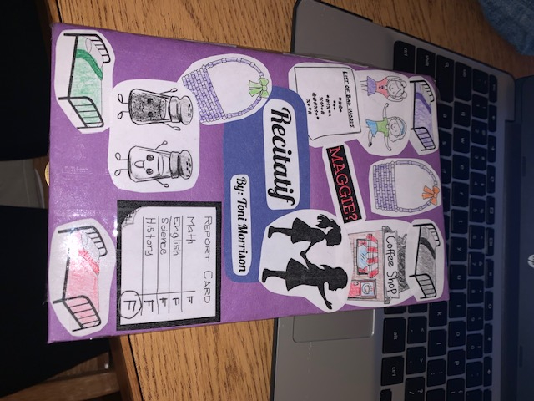

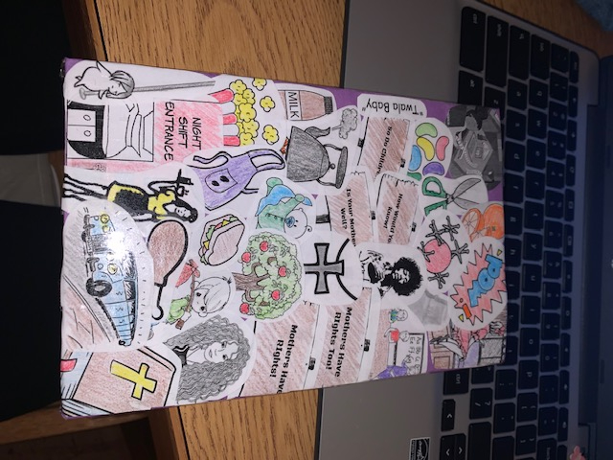

Artist Statement

I did my project on the story by Toni Morrison called “Recitatif.” It's about two girls who were best friends in an orphanage when they were younger. It talks about their lives and how they keep running back into each other. My motivation to do this story was the mystery in it. I loved how she talked about the two girls but never told the readers what their race was. It was a mystery to figure out yourself. Just rereading it I saw so many little quotes that I could make into a collage for the cover. Quotes like “We were eight years old and got F's all the time”(Morrison 1). For this I put a little clipart picture of a report card with all F’s and that would go on the front because they both got F’s. The front is a collage of the things the girls did together. The back is split between both Roberta and Twyla. All the little clipart pictures have a quote behind them. I didn't just put a random picture on there, they all have a significant meaning to them. In the book cover I had girls and women in the pictures were not colored at all. Everything on the pictures is colored except that because of the fact that we have no idea who is what race. This idea I thought was smart and safest without putting my opinions on who is who.
For me it was enlightening to say “Well I think her race is this because of this stereotype.” The inspiration to do the book cover for me was the art part. For me I love art and everything about it so when I heard we could do a book cover I was excited. Being creative on projects like this is something I love to do and this story made it so much more fun. Also with this story you could have done so much more. I had a lot of ideas but the three different collages on the book cover I thought was better. Having to think out of the box on what to put on the cover was fun for me. After hearing the options for the project I switched my story to Recitatif because I had a little idea of what to do for it and built on that.

