Arianna Myers-Arenth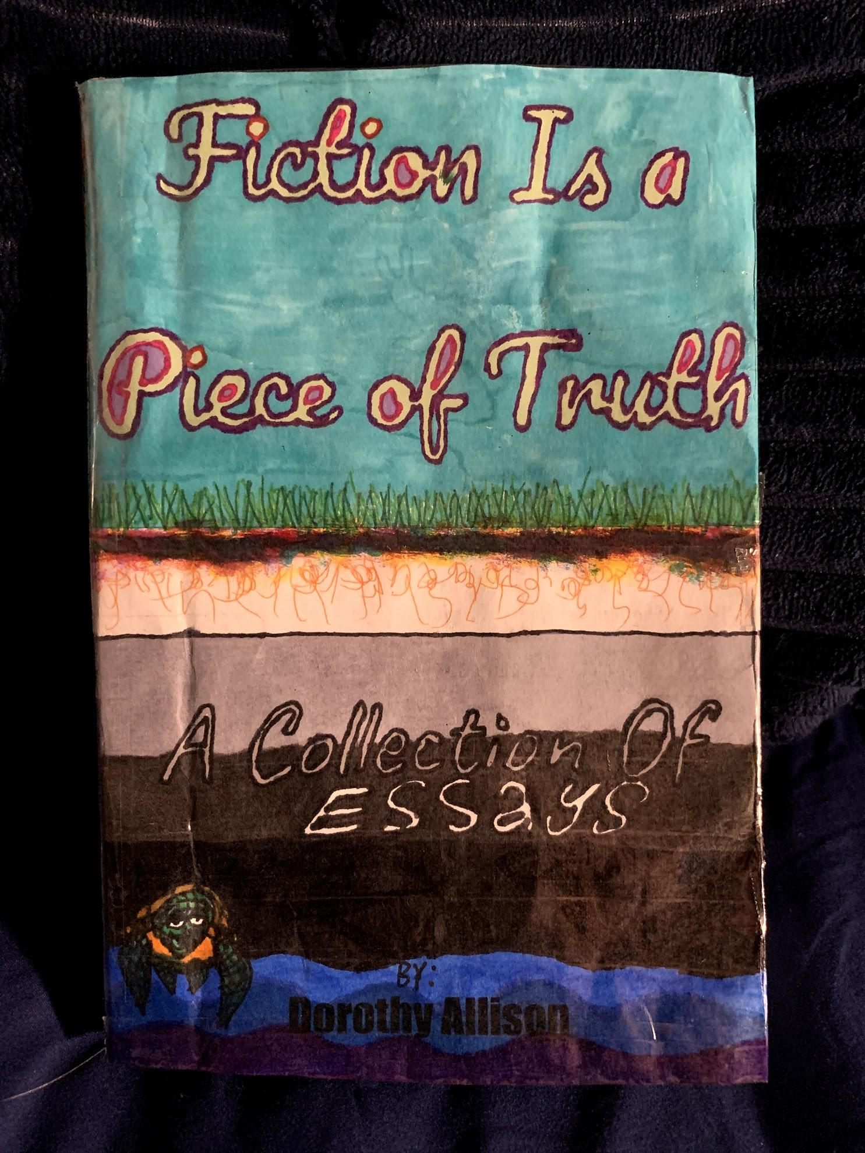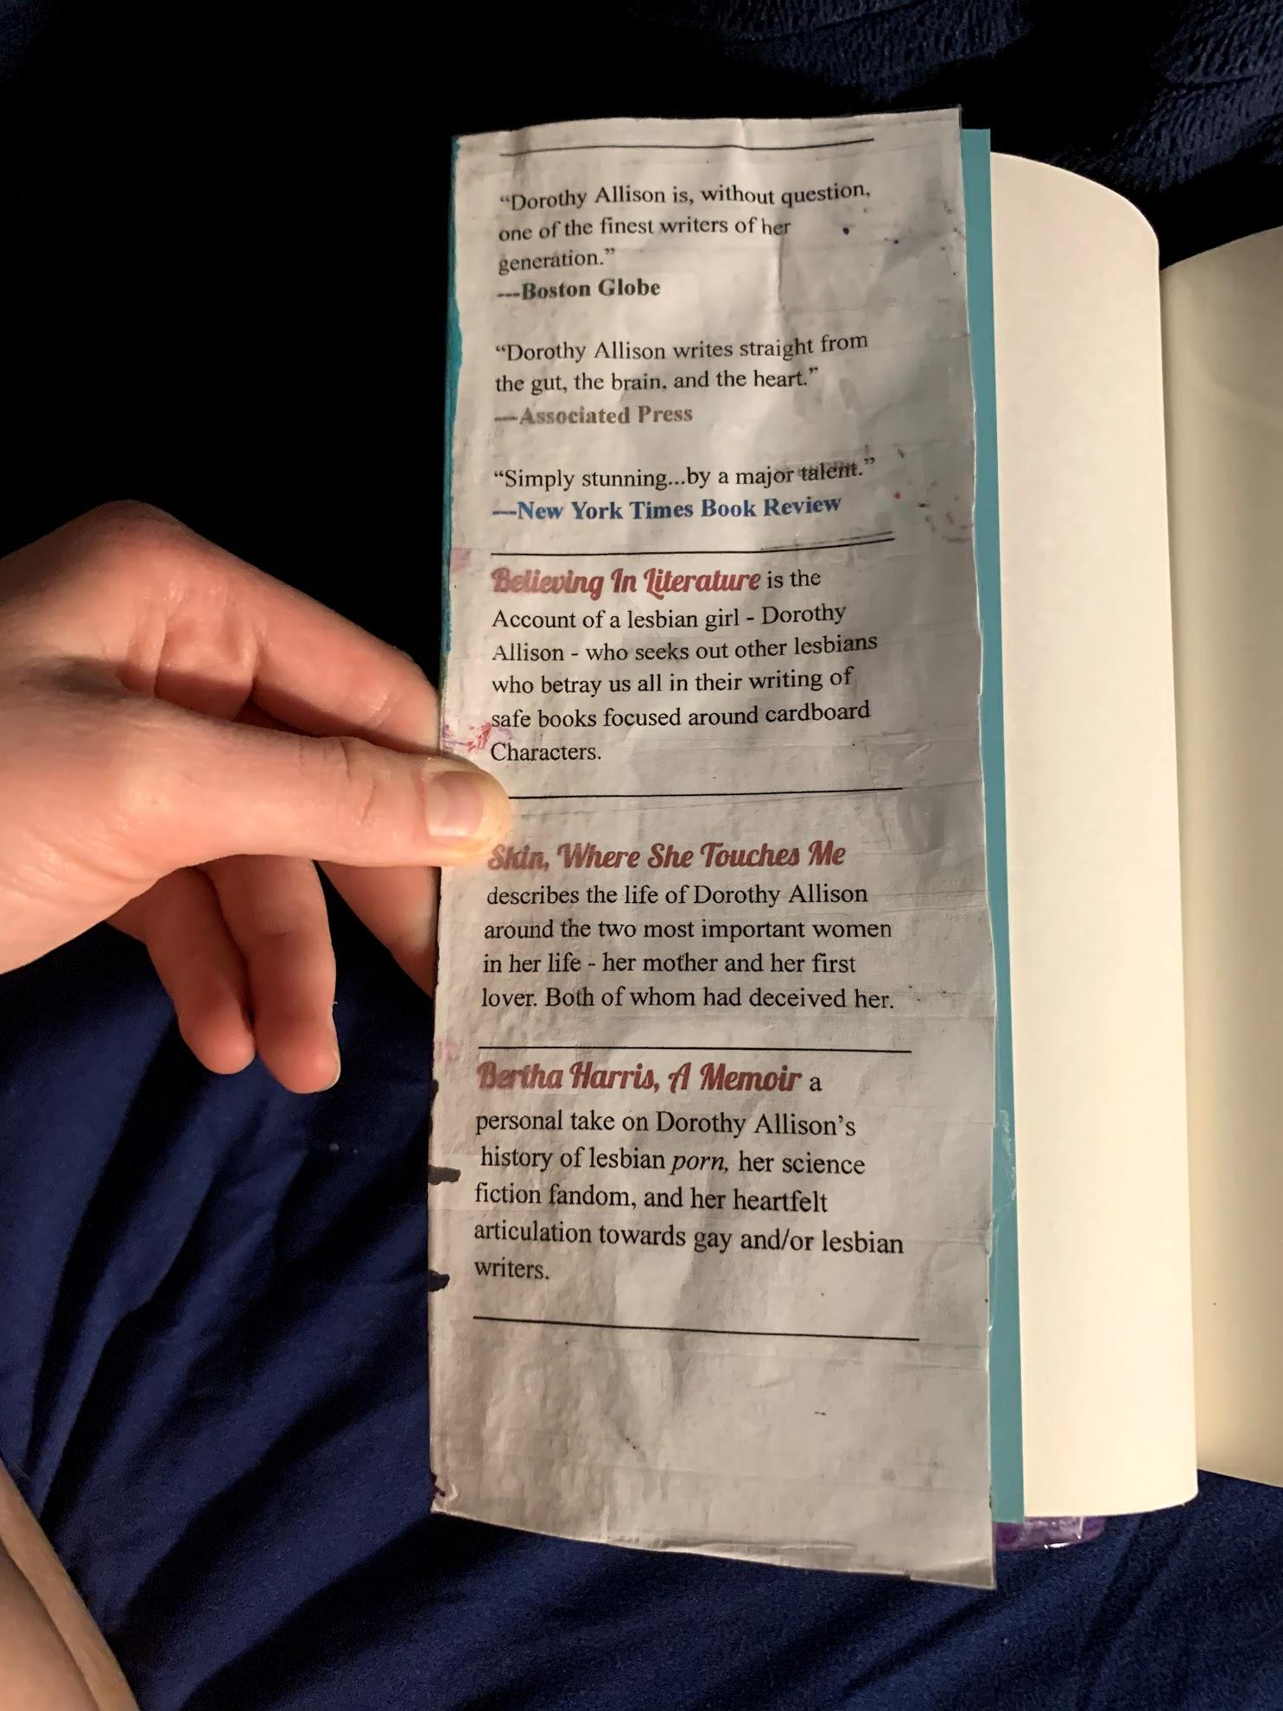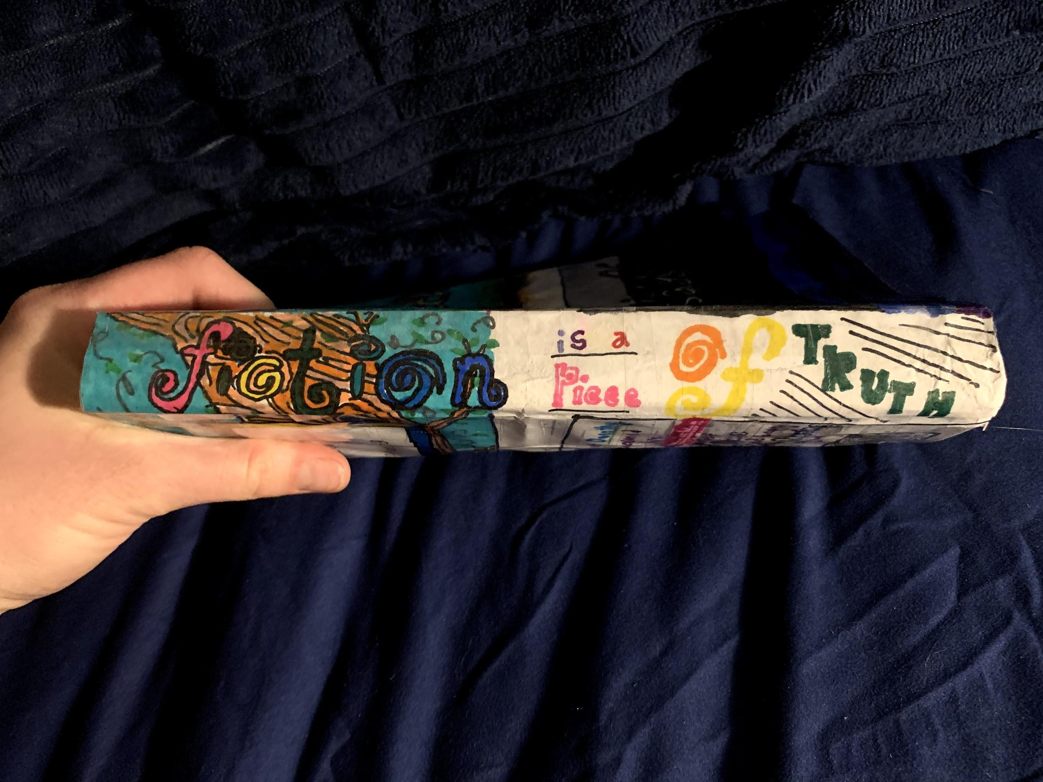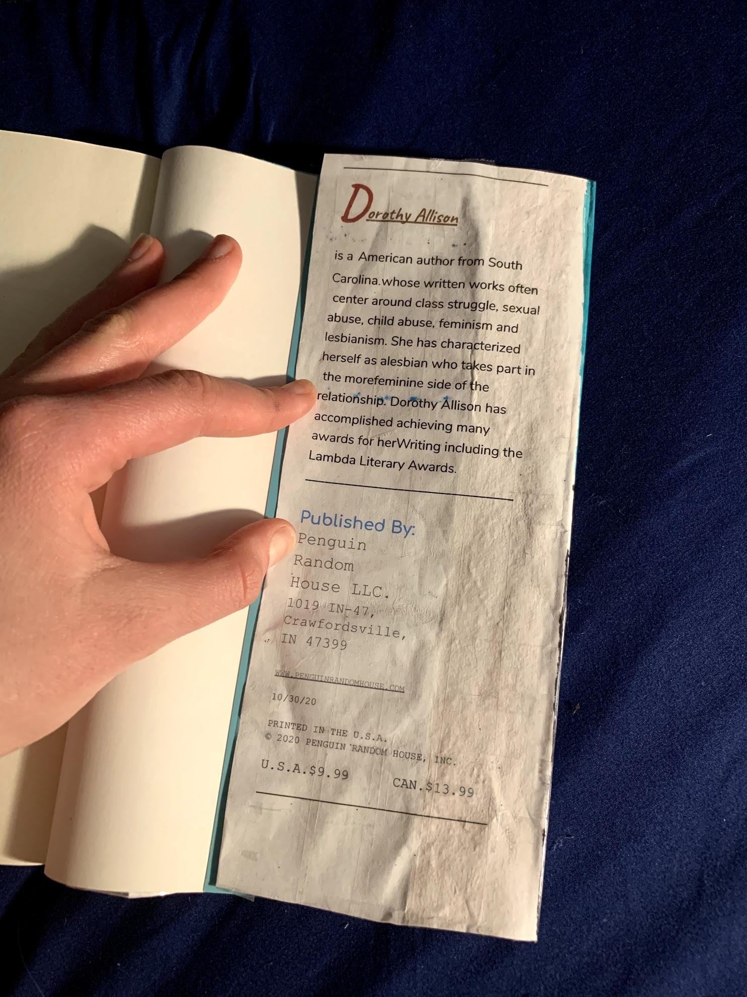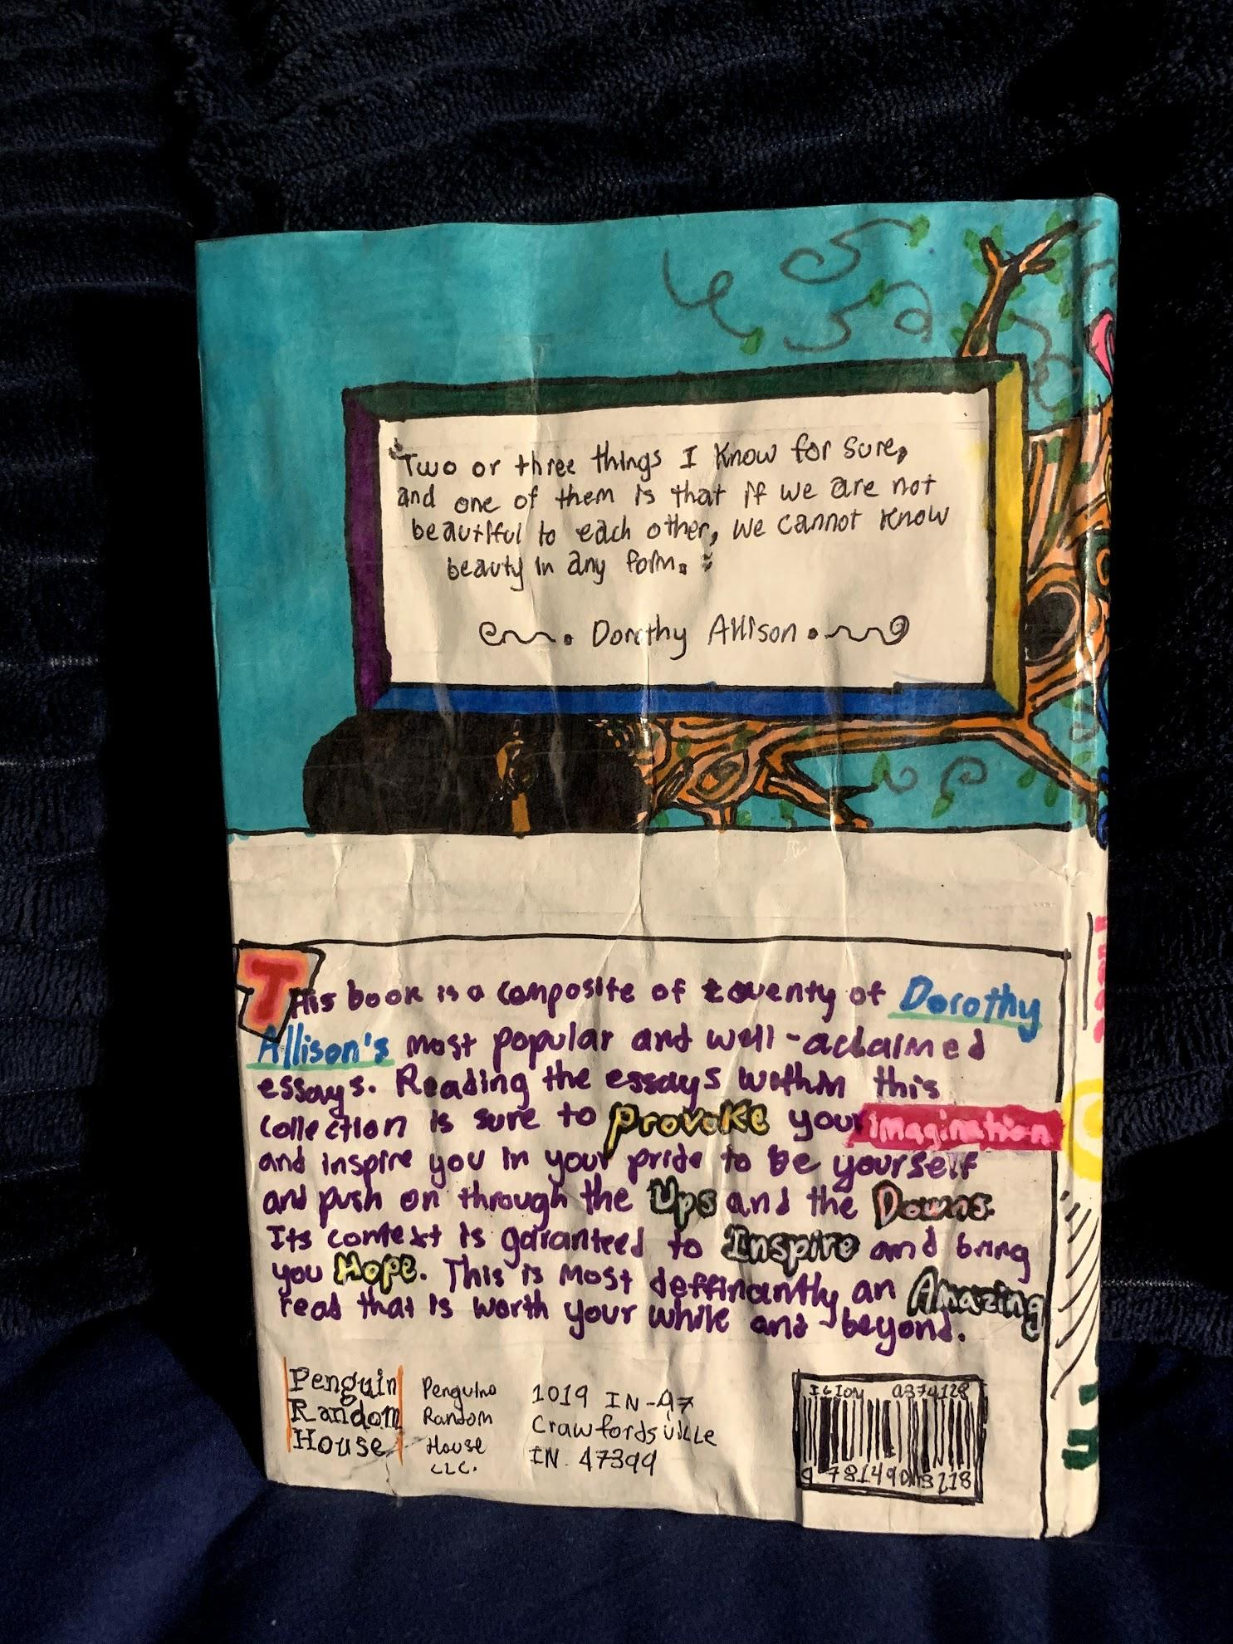

Artist Statement

What had inspired me to follow through with this final assignment in the way that I had was how very much I am able to relate to this author (Dorothy Allison) from my own personal perspective in who she claims to be and what she writes about - more than any of the other authors from which works we have read this semester.
Although it is not exactly the same - and I am aware of that - I consider myself a bisexual, whereas the author Dorothy Allison clearly labels herself as a proud lesbian within a majority of her works, especially when she includes herself within the story as an inside and involved character, or even an outsider reflecting in - as she has done for all of her literary compositions which I have come to read.
Three individual smaller literary essays by Dorothy Allison had particularly impacted me more than any of her other works of literature that we read this semester and these are “Skin, Where She Touches Me,” “Believing In Literature,” and “Bertha Harris, a Memoir.”
I chose to use these three essays by Dorothy Allison for my creative project book jacket because each one recounts lesbian or “gay” culture in a different form and from a different perspective, all of which I felt a deep inward connection towards personally, and I find it important that people understand and respect these ideas and viewpoints just as they would any “straight” outlook on society.
For my book cover I decided to create a sort of “dreamy” appeal because while reading these three essays by Dorothy Allison I felt as though I was moreso dreaming in the context than actually truly reading it. Now I look back at that and I assume that this was because actually reading about these sort of standpoints for the first time largely helped me to realize that these things and feelings I have are not to be silenced and shunned, but rather dignified and expressed with great pride and no fear. As does Dorothy Allison through publicizing her feelings and beliefs through strong and courageous works of literature. Literature that draws people in with its unusual yet compelling details and explanations many people would consider immoral and wrong simply because of its unfamiliarity in this sort of society even to this day as we continue to make all forms of love acceptable.

